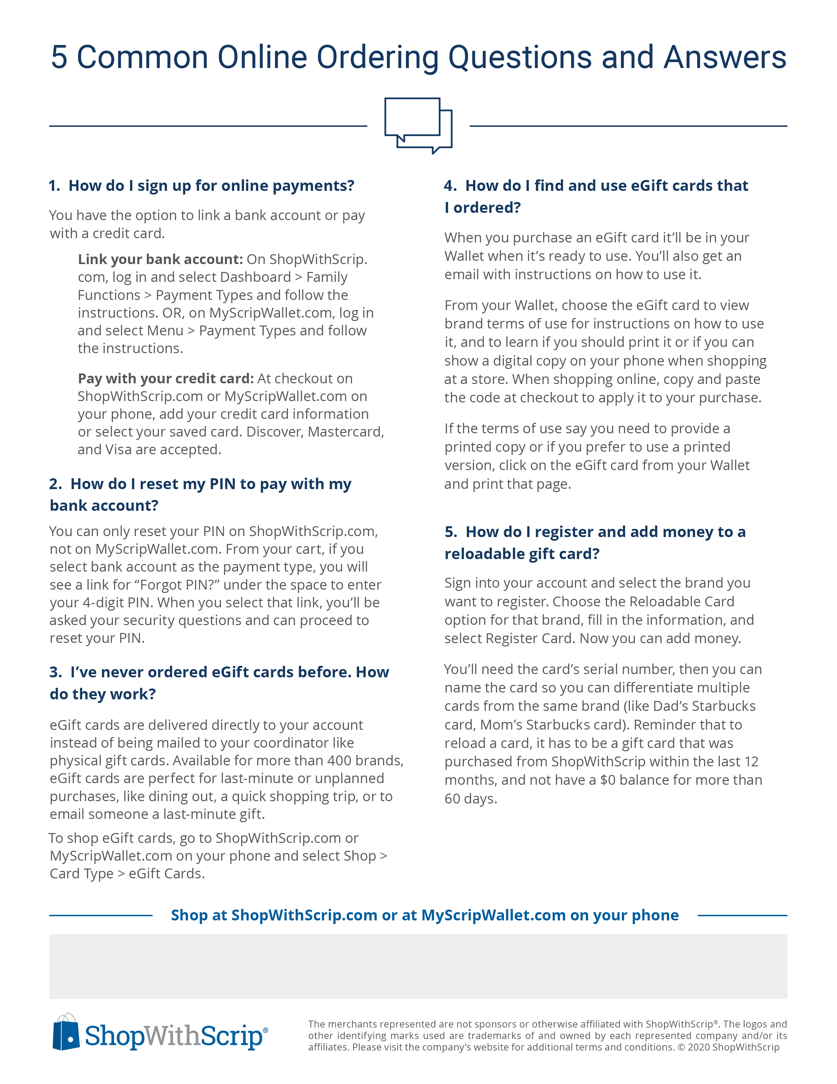

**Your Enrollment Code:** 2B5C42FB16974 **Your Organization:** St Michael the Archangel/ Clayton, NJ

**Your Coordinator:** Christina Figurelli (856) 881-0067 [cfigurelli@hotmail.com](mailto:cfigurelli@hotmail.com)

Orders are due Monday Mornings by 8:30, unless we have Monday off from school, then they are due Tuesday, by 8:30